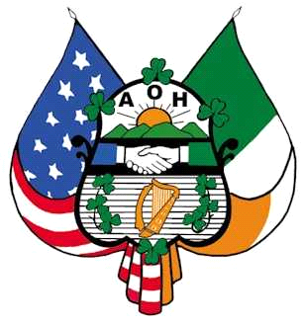
P.O. Box 1724
Savannah, GA 31402

2023 Irish Road Bowling Tournament
Hosted by The Ancient Order of Hibernians - Division 1 Savannah

Dear Sponsors and Friends:

The Ancient Order of Hibernians is a local non-profit dedicated to promoting Irish culture and raising money for local charities in Savannah.

The Ancient Order of Hibernians will host an Irish Road Bowling Tournament on Saturday, March 25, 2023, at the Hutchinson Island racetrack. Road Bowling is a sport from Ireland that involves 3-person teams rolling a 28oz iron ball from a starting line to a finish line. The team with the fewest throws is the winner.

You can help support this event and come join in the fun. Please give us your contact information and pledge one of the following sponsorship levels:

Green Level - $100

- 1 team entry
- Link on our website for one year
White Level - $150

- All benefits of Green Level
- Sponsorship recognition on course

Gold Level - $200

- All benefits of Green and White Level
- 1 additional team entry (2 total)
- Link on website for one year
- Name on main banners around course

Corporate Level - $300+
- All benefits of Green, White, and Gold Levels
- Complimentary authentic steel Irish Road Bowl
- Commemorative plaque

Name: ___________________________Company:___________________________
Contact Number: ___________________________E-mail:_____________________________
Pledge Amount: _______________________
Signature: _______________________________ Date_____________________
Mail Completed Form and Payment: Email scanned copy of completed form:
AOH Road Bowling SavannahAOH@gmail.com
PO Box 1724
Savannah, GA 31402

